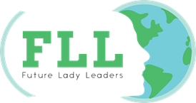

Future Lady Leaders is pleased to share that Fill in Name has generously donated her time to support her community and had the confidence to lead by example with compassion!
She spent # hours supporting Organization at (name location) on (name date) by doing (name activity).
Please contact me if you would like any more details on the great work Fill in Name has done in our community!
Thank you,

Emily Cranmer
President & Founder, Future Lady Leaders Inc.
emily@futureladyleader.com
www.FutureLadyLeader.com

